TEAM Quick Setup Guide

This quick setup guide has been written to assist new users of the Transport Energy Air pollution Model (TEAM), including TEAM-Kenya, TEAM-UK, etc., in getting the model set up. It is designed to complement the comprehensive [reference guide (2019)](https://d2e1qxpsswcpgz.cloudfront.net/uploads/2020/03/ukerc_wp_team_guide.pdf) and the UK Transport Carbon Model (TCM) [user guide (2010)](https://www.researchgate.net/publication/257427154_UK_Transport_Carbon_Model_User_Guide_v10).

**You will need some administrative rights on your machine to make the changes in this guide. Therefore, please notify your institutional IT department *before* you intend to setup TEAM.**

TEAM runs in Microsoft Access, which is available through professional versions of Microsoft 365 (the ‘new’ name for Microsoft Office).

The setup should work correctly if you follow the below steps in the order in which they are laid out. They were written for Windows 11 but should also work for Windows 10.

If you have any questions outstanding, please contact James Dixon ([james.dixon@strath.ac.uk](mailto:james.dixon@strath.ac.uk)) in the first instance.

TEAM was originally developed by Christian Brand at the University of Oxford. For more details, see [here](https://ukerc.ac.uk/project/team-model/).

# Ensure that 32-bit MS Access is installed

To run TEAM, you must have 32-bit MS Access (rather than 64-bit). This is because TEAM uses a set of ActiveX controls to run the graphics, which do not work on 64-bit Microsoft applications. To find out the version of MS Access you’re using, open Access and navigate to Account (on the bottom-left) and then ‘About Access’. The version will be displayed on the top line. For most default applications, expect this to say 64-bit.

If you do not have Access installed, or have the 64-bit version installed, then you will have to install the 32-bit version. 32-bit version of MS Office apps can be installed through [Microsoft 365](https://www.office.com/?auth=2).

You will **first** have to uninstall any 64-bit version of MS Office (search ‘add or remove programs’ on Windows taskbar).

You can then navigate to Microsoft 365. Click the dots at the right-hand side, and click uninstall. Follow the instructions.

Then, to install 32-bit Office, go to [Microsoft 365](https://www.office.com/?auth=2). After signing in, from the home tab, you should be able to see an ‘Install Apps’ button. Click, and then click ‘other install options’.

Then click ‘Apps & devices’ and set the version drop-down box to 32-bit. Click ‘Install Office’ and follow the instructions.

In the Version drop-down menu, select ’32-bit’.

This will install 32-bit versions of **all** Microsoft 365 applications on your machine. If this proves to be disadvantageous, you can follow these same steps to go back to 64-bit but you will not be able to use TEAM. 32-bit versions work perfectly well on most PCs, such that you will not be able to tell the difference.

# Change the MaxLocksPerFile value in your registry

MaxLocksPerFile is a Microsoft registry setting that sets how many selected cells in an application such as Access can be modified at one time. The default value of MaxLocksPerFile is too low for TEAM to work.

It is easy to adjust the registry settings, though you may need to seek institutional IT department help to gain administrator rights. See guidance (Windows) below, adapted from guidance found [here](https://social.technet.microsoft.com/Forums/en-US/1e152f31-3b5e-424b-b6a1-2a1651a909be/how-to-update-the-maxlocksperfile-registry-for-microsoft-access-for-office-365-64bit?forum=Office2016ITPro).

Go to ‘Registry’ or ‘Registry Editor’. Find this by searching ‘registry’ in your start menu.

The easiest way to find the MaxLocksPerFile option is to:

1. Navigate using the dropdown on the left-hand side to **HKEY_LOCAL_MACHINE\Software**
2. Use the find tool (Edit>Find, or Ctrl+F) and search for **MaxLocksPerFile**.

Select MaxLocksPerFile on the right-hand side by double-clicking. Click on Decimal for the base. The **default value** is 9500 which is too low for TEAM to run.Change to **128000**, click OK and exit registry.

Note that **messing around with the registry editor can** **cause serious errors within your PC.** So take care when changing this option, and don’t set it higher than 128,000!

If you are running TEAM later and get the following error: “Caused by: File sharing lock count exceeded”, then this has not worked. Try the above steps again.

# Link the ActiveX Graph Control

Open MS Access for the first time. Load the TEAM instance you’re trying to work on, by clicking open, navigating to the location of the model supplied and opening the database file EXP_TEAM-KEN_v1.

Opening the TEAM instance for the first time, you’ll get an error message regarding a macro called ‘AutoExec’. This is because there is a missing reference to the ActiveX Graph Control, which is stopping the Graphical User Interface from loading.

To fix this, first click ‘Stop All Macros’. You may also get a message about secure content – if you do, click Enable Content. Then, navigate to ‘database tools’ at the top and go to ‘Visual Basic’.

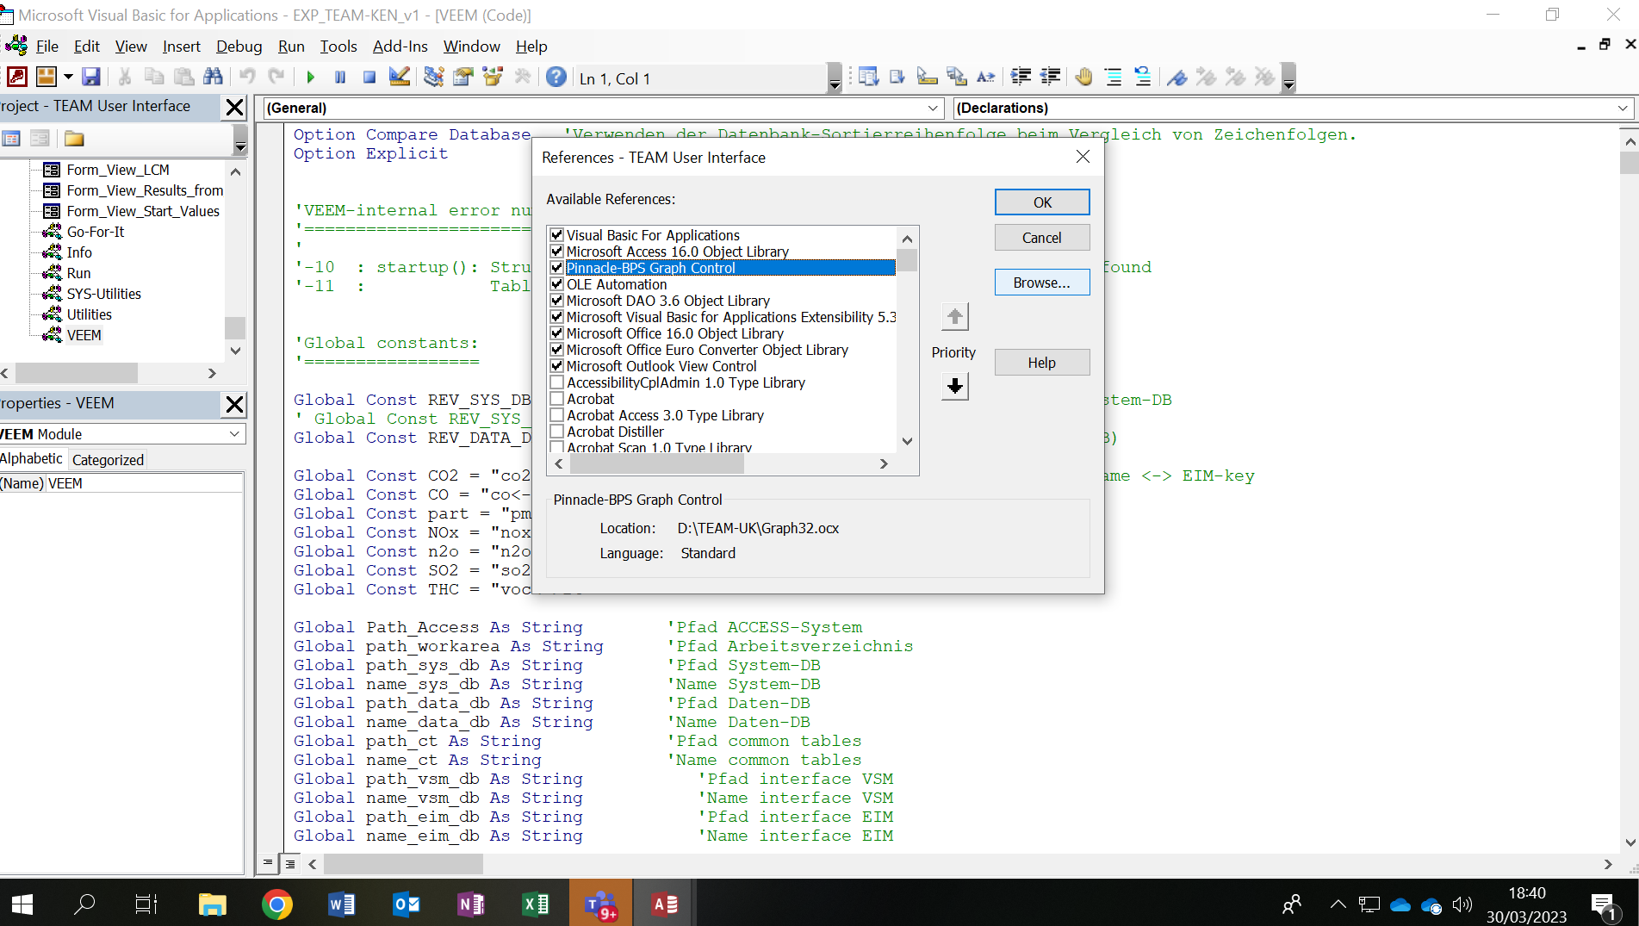

Then when the VBA window opens (above), click ‘Tools’ and ‘References’. If the graph control is missing, then it will say ‘MISSING: Pinnacle BPS Graph Control’. Click it (so it’s highlighted in blue), and then click Browse.

Navigate to the folder where the model is and select file type (bottom right) as ActiveX controls. You will see a single file, Graph32.ocx. This is the ActiveX control you need to link to TEAM in order to make the graphics work. You may also need to ensure permissions are granted to this file – right-click and select properties. Go to the security tab, and ensure the permissions are as follows.

If the permissions differ from those listed above, click edit and assign accordingly. Then click OK, select Graph32.ocx and click Open. That should link it up.

Afterwards, go to Database Tools > Compact & Repair > Save. Quit MS Access, and re-open.

You have now completed the setup. Your MS Access window should now look like the below.

